**Exercise 1: Scheduling (10 points)**

Make a research in the internet and the library about the following properties:

1. What is Priority-Inversion?
2. What is Priority-Inheritance?

Citations of at least three different sources are expected. Are the definitions and explanations consistent or do you think there are differences?

Explain with you own words the two properties and “invent” an illustrative example.

(This Exercise is a training for scientific work like bachelor or master thesis!)

**Exercise 2: Resources (10 points)**

There are 3 periodic Tasks Ti(texec; tp; rs; re).

• texec is the execution time of the task,

• tp is the period (deadline),

• rs the starting point (after start of task) of the resource usage and

• rethe time the resource is needed

Please do a schedule for

T1(9; 25; 2; 2); T2(2; 10; 2; 1); T3(5; 15; 3; 2) with RMS (including resources) without additional resource management.

**Exercise 3: Resources (15 points)**

(a) Do a schedule for the tasks   
T1(12; 45; 6; 7); T2(9; 20; 0; 0); T3(2; 11; 1; 2) and show, that

there is a resource conflict.

(b) Please show, that there is a solution using priority inheritance.

**Exercise 4: Petri Nets(20 points)**

Read the paper attached to these exercises about Petri-Nets carefully. Afterwards you should work out:

1. What is the differences of the simple Petri-Nets compared to the lecture
2. Explain the differences of Petri-Nets and Inheritance-Nets
3. Explain the differences between simple and coloured Petri-Nets.
4. Explain the differences between simple and timed Petri-Nets.

Differences means structural differences, additional characteristics and behaviour and for what application scenarios they are adequate (There are books in the libraries and a lot of good lectures in the internet about the stuff.

(This Exercise is a training for scientific work like bachelor or master thesis!)

**Exercise 5: Petri net (15 points)**

Is the petri net in the figure alive and/or safe ?

A detailed prove is required!

For testing liveness use a reachability graph !

A reachability graph is required.

If you don’t know the properties, refer to the attached paper or

other papers or books.

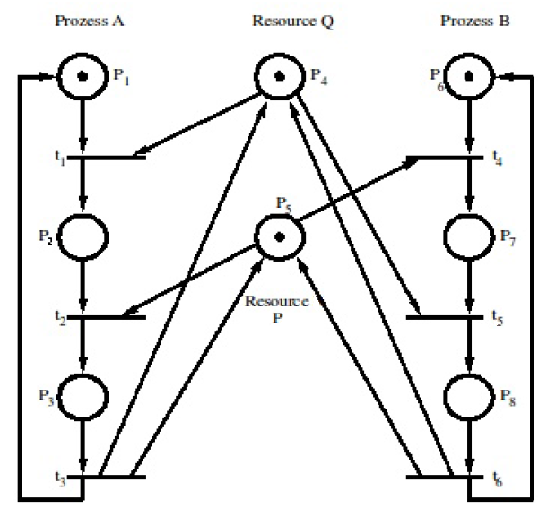

**Exercise 6: Petri net (20 points)**

Develop a packet sorting machine, which should meet the following specification: You have a conveyor band with two photo sensors. The sensors will produce the signals S1 and S2. The packets have different sizes (L1 and L2).

Following rules exist:

• L1 < L < L2

• L < d + L1

(d: minimal distance between two arbitrary packets/  
MindestabstandzwischenzweibeliebigenPaketen)

• An object inside the photo sensor will produce Si = 1



If the sorter detects a small packet, the output (O) will change to one ( O = 1), until the packet reaches the next photo sensor. In all other cases the Output is zero (O = 0)

Hint: model the rising and falling edges of the photo sensors S1, S2 as transistions. Youcan use a simulator. To start the simulator try: pneditor.sh

**Exercise 7: Finite State Machine (20 points)**

Develop a Finite State Machine for the packet sorting machine of exercise 7.

You might use qfsm.

**Notification:**

For the testate you need exercises of at least 60 points in a very good quality! If you deliver more than these minimum exercises the quality might be only good! I recommend to try all.